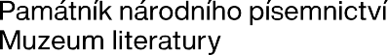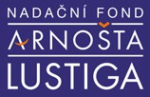

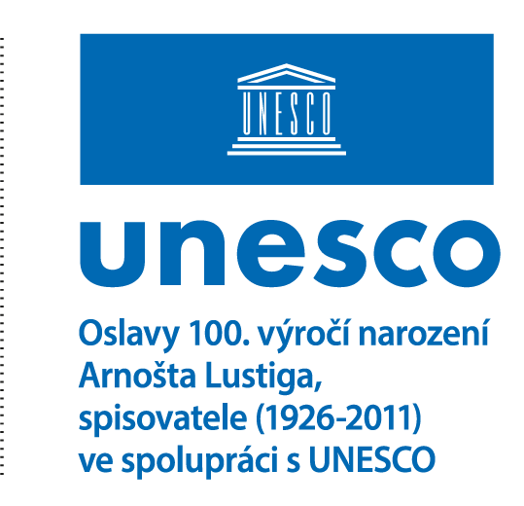

PRESS RELEASE / Prague
ARNOŠT LUSTIG FOUNDATION AND THE MUSEUM OF LITERATURE / MEMORIAL OF NATIONAL LITERATURE PRESENT THE CELEBRATIONS OF THE 100th ANNIVERSARY OF ARNOŠT LUSTIG'S BIRTH
Date: December 3, 2025

"My heroes are unheroic, ordinary people whom fate, history, or chance places before decisions that cannot be avoided. Who I am, who I am not, what a human being is, what courage, honor, hope, conscience, and desire are." Arnošt Lustig

The Arnošt Lustig Foundation, together with the Museum of Literature / Memorial of National Literature, presents the celebrations of the 100th anniversary of the birth of the writer, journalist, screenwriter, and Holocaust witness Arnošt Lustig (1926–2011). International celebrations will take place in 2026 under the unified name FestivAL100, connecting ten countries across four continents. As a celebration of humanism, the multi-genre program will offer artistic and cultural events, publications of previously unreleased works, exhibitions, educational programs for students, and literary competitions.

The 100th anniversary of Arnošt Lustig's birth was officially approved at the 43rd UNESCO General Conference in Samarkand as one of the significant anniversaries with which UNESCO will be associated in the 2026–2027 period. Similarly, Tomáš Baťa was granted a place on this prestigious UNESCO list for the 150th anniversary of his birth, representing extraordinary recognition of the importance of Czech social and cultural heritage.

Arnošt Lustig’s legacy and his centenary are championed by his daughter, Eva Lustigová, co-founder of the Arnošt Lustig Foundation, together with renowned institutions of FestivAL100 from the Czech Republic and abroad. "The Museum of Literature / Memorial of National Literature (PNP) is working closely on FestivAL100 to commemorate the personality and extraordinary work of the writer Arnošt Lustig in 2026... I believe our cooperation will result not only in a successful project as such but, above all, in reaching the wider public thanks to the legacy of Arnošt Lustig's work," stated Michal Stehlík, Director of the PNP. Reflecting on the partnership, Tomáš Kubíček, Director General of the Moravian Library (MZK), added: "We are delighted to join the celebrations of one hundred years since the birth of Arnošt Lustig, an exceptional Czech writer, intellectual, and human being, whose civic stances continue to provide a moral compass for our society." In connection with the jubilee, René Zavoral, Director General of Czech Radio (ČRo), noted: "Not much is known about Arnošt Lustig’s beginnings at Czech Radio... I see our media partnership for the Festival for his 100th anniversary as a symbolic connection. We must continue to remind the public of the values he emphasized in his work. It is a major task for the media to point this out. One should have a clear conscience."

The festival celebrations are divided into four main sections: literature, exhibitions, music, theater and film, and education.

Literature: Presentations of literature, preparation of exhibitions, and other showcases will be the focus of the Museum of Literature, the Moravian Library (MZK), the Terezín Memorial, Štetl fest, Meeting Brno, libraries in Kutná Hora, Nymburk, and Opava, and the Arnold Villa in Brno. The Arnošt Lustig Fund and Archive will open at the PNP, and the Arnošt Lustig Library will open at the MZK.
A round table with literary scholars at the Václav Havel Library in Prague will be dedicated to a critical look at the literary contribution of Arnošt Lustig's prose. At the Gallery of the Central Bohemian Region (GASK) in Kutná Hora, a Student Round Table, an exhibition inspired by Lustig’s short stories, and a film screening with a discussion will take place.

The ANNIVERSARY BOOK EDITION will offer a range of selected internationally acclaimed short stories, novels, and existential essays, as well as a surprising collection of early works, where readers will encounter the author's "young voice" in book form for the first time.
At Book World Prague, this anniversary edition will be presented by leading publishers from the Czech Republic, Vietnam, and Croatia, alongside new audiobooks of Lustig's stories voiced by prominent performers, and Markéta Pilátová’s graphic novel Arnošt’s Journey with Miloň Čepelka. A significant collection of Arnošt Lustig's fiction, prepared by the Municipal Library in Prague, will also be presented. Insight into the background of the most significant places associated with the author's birthplace will be offered by the literary walk "Arnošt’s Libeň," designed by the Prague 8 district and poet Vít Janota.

FestivAL100 also builds on the writer's legacy with leading literary figures, including journalist Petra Procházková, poet Petr Borkovec, dissident poet and publisher Dmitry Strotsev, writers Karel Hvížďala, Markéta Pilátová, and František Cinger, and Binh Slavická, the translator of A Prayer for Katerina Horovitzova into Vietnamese.

EXHIBITIONS
The Museum of Literature, the Moravian Library, and the Terezín Memorial will feature multimedia exhibitions dedicated to the literary work and life of Arnošt Lustig, both permanent and touring. The international traveling exhibition "I Want to Be Human – Arnošt Lustig's Message to the Stars and Beyond" will travel to the planetarium in Netanya, Israel, and various locations in the Czech Republic. The exhibition unconventionally depicts how a person can survive the unimaginable and maintain humanity despite its fragility in a rapidly changing world. It also highlights the gap between impressive scientific progress and our insufficient efforts to cultivate humanity, which leads to general backwardness in this regard. The web portal "The World of Arnošt Lustig," created in cooperation with the Moravian Library, will introduce visitors to the life journey and world of Arnošt Lustig.

MUSIC, THEATER, AND FILM
Arnošt Lustig's work will be expanded into new forms by selected actors and artists. In the lyrical-musical program titled "Cantata – Dance of the Mad," held at the Maisel Synagogue in Prague, Jiří Lábus, Vilém Udatný, and Máša Málková will recite Lustig's only, unknown, and previously unpublished poem Shevirat HaKeilim (The Breaking of the Sacred Vessels). The essence of the poem will be enhanced by Johann Sebastian Bach's famous cantata Ich habe genug (BWV 82), performed by opera singer Marie Kopecká Verhoeven and the Barocco sempre giovane chamber orchestra. Lustig's prose will be presented through the "Listování" stage reading series directed by Lukáš Hejlík across the Czech Republic, or dramatizations of short stories directed by Eva Lustigová with a host of leading actors, such as Jiří Lábus, Tereza Kostková, Carmen Mayerová, Petr Kostka, Helena Herfortová, Lary Hauser, Oldřich Smysl, and Šimon Franz. Dramatizations in the Czech Republic will be enriched by clarinetist Anna Paulová and composer/accordionist Jiří Lukeš; abroad by violinist Jana Vonášková, the South Bohemian Philharmonic chamber orchestra, and Barocco sempre giovane. A world premiere of DANCE THEATER inspired by a story from Arnošt Lustig’s "Golden Fund" is planned, featuring young dancers from Bohemia Ballet under the direction of Jaroslav Slavický, directed by Tomáš Vondrovic, with choreography by Lukáš Slavický and music by Petr Malásek. Film festivals such as the Zlín Film Festival and the National Film Archive's Ponrepo cinema, the Blue Cross in Kutná Hora, and other screenings will show internationally awarded feature-length, short, and documentary films based on the author's screenplays and stories. The films will be intended for the general public as well as schools, accompanied by discussions moderated by filmmakers and journalists.

EDUCATION AND DEVELOPING LITERARY TALENT
The 2nd year of the international literary competition "Young HUMAN-ists" will contribute to the development of creative talent while strengthening humanistic and democratic values among high school students from Brno, St. Pölten (Brno’s partner city), and Vienna with a cross-cultural reach.
A series of educational workshops focused on civic and value-based education, literature, and history for all three levels of schooling in the Czech Republic are already part of the permanent offer of Charles University’s Didaktikon for the 2025–2026 school year and planned through December 2026. Other workshops will be based on methodology prepared by the Museum of Literature for the exhibition "Witness to the Disruption of Humanity," the Foundation’s international traveling exhibition "I Want to Be Human," and the Higher Professional School of Journalism in Prague. Methodological sheets for teachers and worksheets for students will be available during the workshops.

The festival takes place under the auspices of:
- Petr Pavel, President of the Czech Republic
- Doc. MUDr. Bohuslav Svoboda, CSc., Mayor of Prague
- JUDr. Jiří Pospíšil, Deputy Mayor of Prague
- JUDr. Markéta Vaňková, Mayor of Brno
- Mgr. Terezie Radoměřská, Mayor of Prague 1 District
- Mgr. Jan Grolich, Governor of the South Moravian Region
- Mgr. Klára Šimáčková Laurenčíková, Government Commissioner for Human Rights
- Czech Commission for UNESCO
- Federation of Jewish Communities in the Czech Republic
- Embassy of the Czech Republic in Germany, France, and Austria
The festival is supported financially:
- The City of Brno
- South Moravian Region
- City of Prague
- Foundation for Holocaust Victims
- Austrian Cultural Forum, Dominique Defontaines
- Vladimír Polách (Attorney)

Kontaktní informace:
Eva Lustigová, MBA
Arnošta Lustig Foundation
Co-founder, Chairwoman of the Board
lustigova@lustigfoundation.cz
+41 79 477 3206 / +420 776 813 139

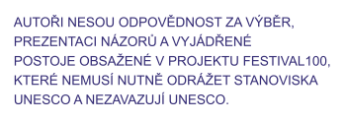

The round table on Arnošt Lustig‘s contribution was supported by:
- Prague 1
- Czech Literary Fund Foundation
- Jewish Community of Prague Foundation
Main Media Partner:
- Czech Radio
Other Media Partners:
- NPI EduRevue
- Vídeňské svobodné listy
- Nová Večerní Praha
- Maskil

See other partners

More about FestivAL100
More about Arnošt Lustig

